WARRANTY: There is a full 2 year Parts and Labour Warranty on the Vinetech Birdscarer. Any liability or claim against Vinetech shall not exceed the purchase price.

NOTE: Remove battery at the end of the season.

The effectiveness of this device will be improved with shotgun backup

VINETECH
Electronic
Birdscarer
INSTRUCTION MANUAL
Assembly and operation
Vinetech
Electronic
Birdscarer
IMPORTANT
Read before use
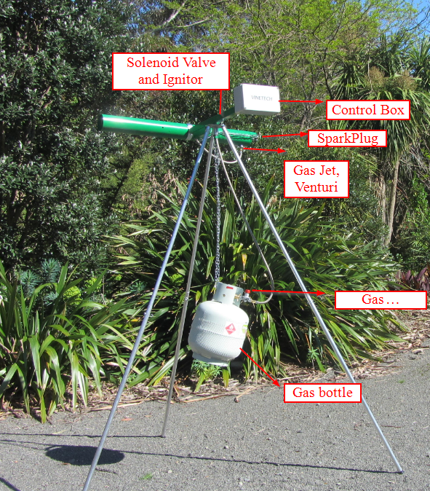

AVAILABLE ACCESSORIES
Spare rechargeable batteries
Solar panel charging option

SAFETY PRECAUTIONS

- DO NOT operate birdscarer where surrounding materials may catch fire
- Use LPG only
- Operate birdscarer in an open area
- Ensure legs are on stable ground to prevent tipping over.
- Frequently check barrel for obstructions and clear if necessary.
- Never operate the birdscarer without spark plug leads connected otherwise damage to the circuit board could occur.
- Always wear hearing protection when in the vicinity of an operating birdscarer

For further information contact:
Vinetech Birdscarers
Unit 4, 602 Omahu Road
Hastings, 4120

Ph: 027 3897651 email: enquiries@vinetechbirdscarers.com

