ASSEMBLY

- Remove the birdscarer from the box leaving the cable tie in place at this stage.

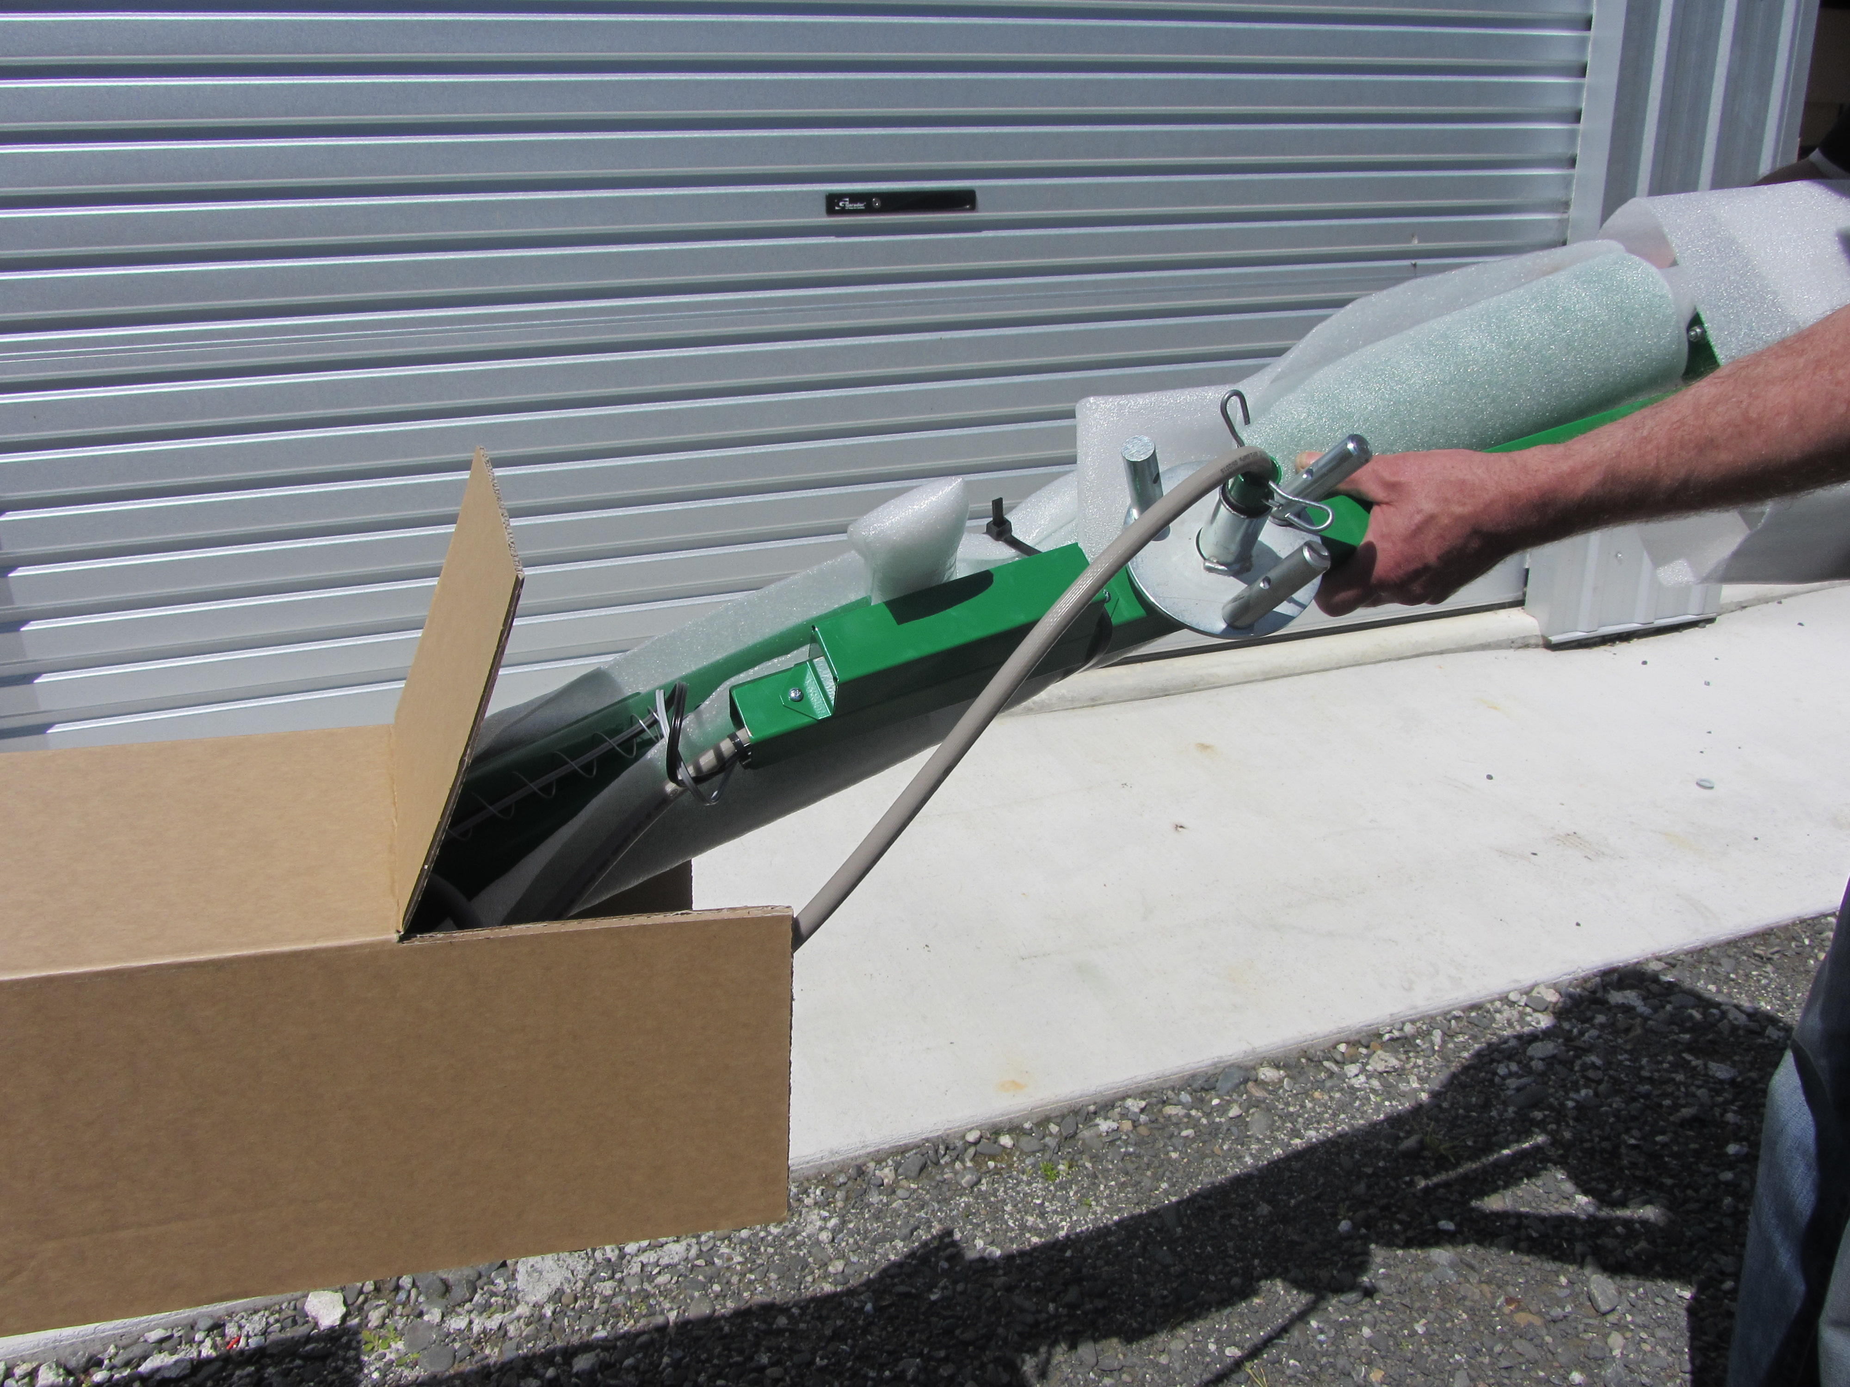

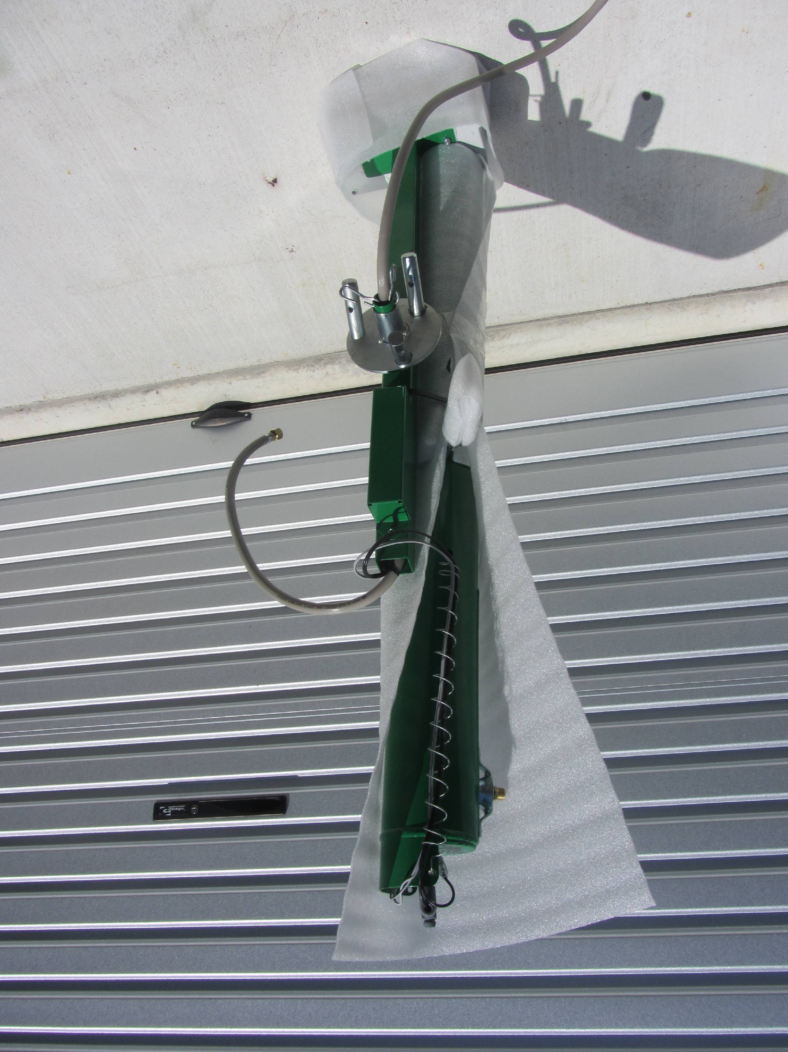

- Stand the unit vertically with the control box at its base and remove the 2 bolts from the barrel bracket and keep them handy.
- Hold the barrel firmly and cut the cable tie.

- Slide the barrel bracket into the arm and using the 2 bolts, bolt the barrel to the arm. Tighten firmly.

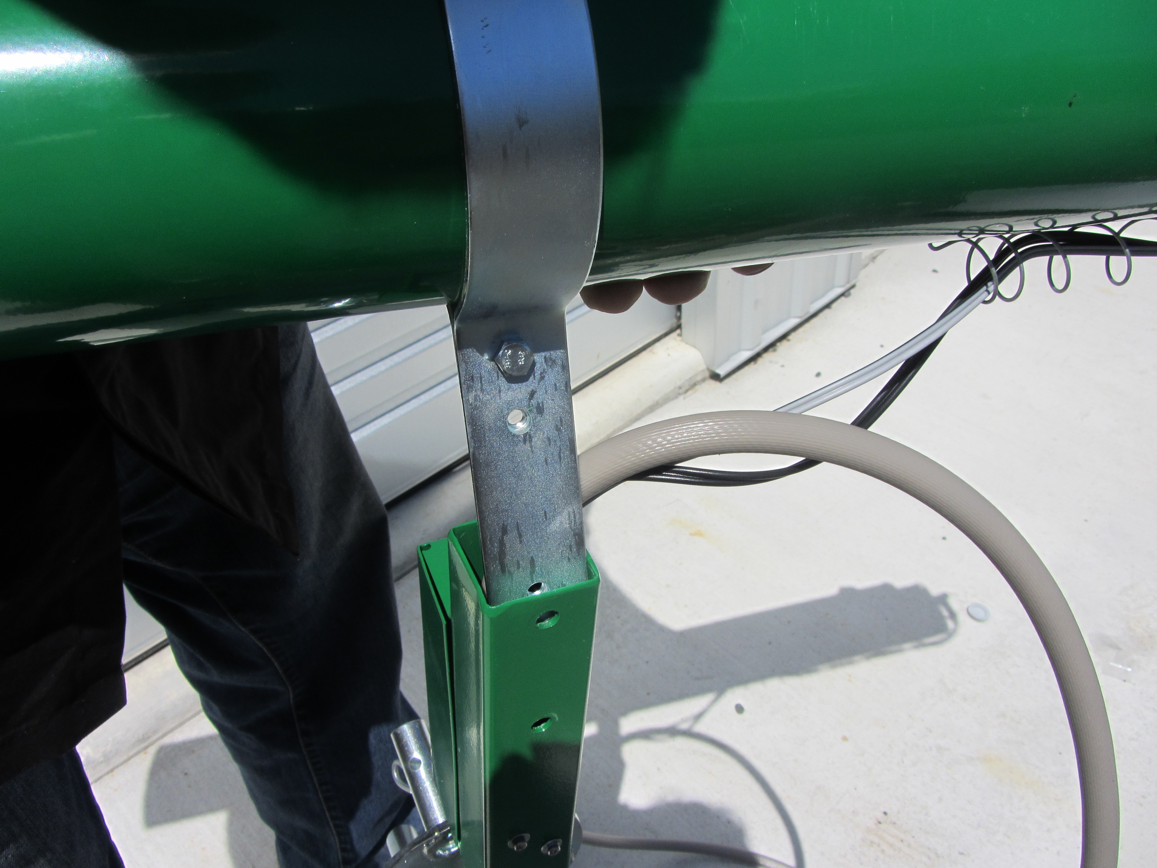

- Screw the gas hose to the jet and tighten.

- Assemble the 3 legs. The green dot is the top end, slide the other end into larger leg piece, align the holes and fit spring clip into place.

- Lay birdscarer flat on ground and attach legs to tripod top, aligning the holes and fitting spring clips into place.

- Swivel the two moveable legs inwards and rest the birdscarer with the barrel on the ground and the control box uppermost. This gives easy access to the control box and is also the best resting position for the birdscarer.

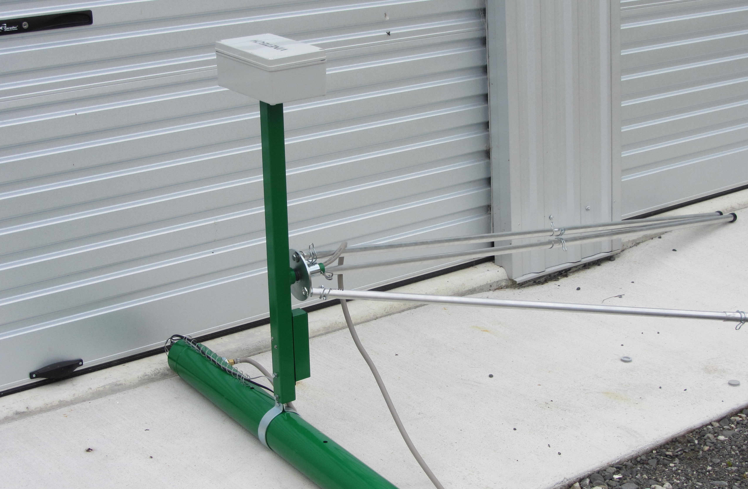

IF THE BIRDSCARER IS LAID DOWN WITH THE LEGS ATTACHED FOR ANY REASON (HIGH WIND, ETC) IT NEEDS TO BE RESTING ON THE BARREL WITH THE CONTROL BOX UPPERMOST – SEE PICTURE ABOVE

- Remove the control box cover and timer instructions

- Connect the battery terminal. The birdscarer is factory set to operate with the light sensor option automatically turning on at daylight and switching off at dusk firing 3 shots per group. These settings are adjustable – see page 5. If you wish to have specific on/off times, use the timer option. Go to page 8 and follow timer setting instructions.
- Replace the control box cover

- Hold the legs and stand the birdscarer upright. Once in the upright position, swivel the two moveable legs open to give a uniform tripod configuration.

- It is easy to move the birdscarer around the property without removing the legs. Just remove the gas bottle, swivel the two moveable legs together again and hold it in the upright position to relocate. Open the legs again into a uniform tripod configuration.

- The gas bottle.
Before fitting the regulator to the gas bottle and suspending it on the chain, it is good practice to purge your gas bottle because stale gas can be trapped even in a new bottle. Use only fresh LPG.

Purging your gas bottle

Good practice is to purge the bottle by opening the valve for 2-3 seconds before fitting.

To purge your gas bottle (before attaching regulator) open main valve then open purge valve with screwdriver as shown. Just a short burst 2-3 seconds, then close purge valve. Close gas bottle valve.

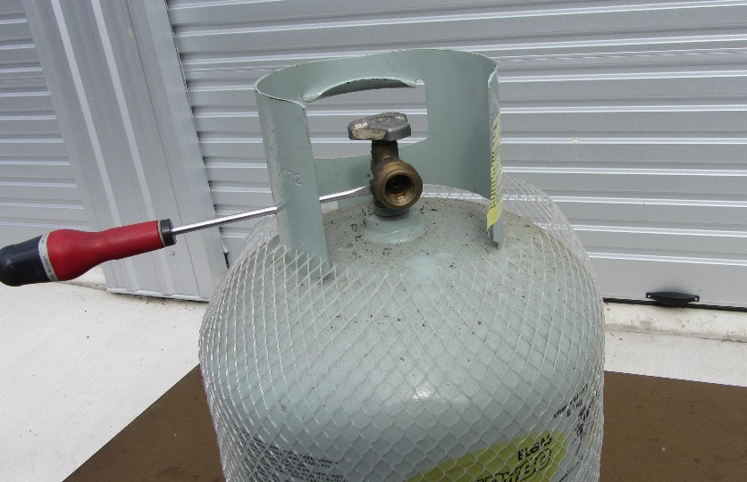

- Hook one end of the chain provided to the hook on the tripod. Now thread the chain through the gas bottle handle and lift the gas bottle and hook the other end to the second hook on the tripod.

16. Remove protective cover from the regulator and connect to the gas bottle and tighten firmly by hand. Store the protective cover in the control box for any time the regulator is disconnected. The regulator is pre-set to maximum performance. The sound level of the unit can be reduced by turning the regulator knob anti-clockwise until desired sound level is achieved.

GAS BOTTLE MUST BE KEPT IN AN UPRIGHT POSITION

- The unit is ready to go. PUT YOUR HEARING PROTECTION ON.
Turn the gas on, turn the knob on the control box to the No 3 position. This will give 12 groups of 3 shots at random intervals per hour (refer to page 5 Time Delay options if you wish to alter this). There is a 35 second delay before the first firing when first activated.

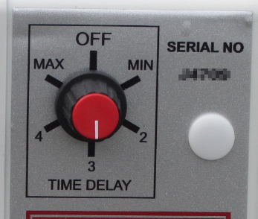

OPTIONS

- Option 1 –Light Sensor - the birdscarer comes factory set in this option and if you wish to use this option, you only have to switch the birdscarer on.

- When switched to this mode, the birdscarer will automatically turn on at daylight and turn off at dusk.
- The Light Sensor Adjustment – (shown in the PCB Board picture) the adjustment has been set to average conditions but if you do wish to adjust it, a small movement either way (e.g. from 8 o’clock to 10 o’clock) should give you your desired result.
WARNING: settings past the 10 o’clock position could cause the birdscarer to operate when a full moon occurs.

- Option 2 - Digital Timer – if you wish to use this option, move the switch marked “A” (on the PCB picture) to the clock positon.

Follow the timer instructions on page 8 to set your required on/off times.

- Time Delay Program and Number of Shots per Group Selection

- The time delay program is the time between the groups of shots and is set when turning the unit on with the dial on the control box to the desired position.
Minimum – is the shortest time between groups of shots and will fire 20 groups randomly per hour

Maximum – is the longest time between groups of shots and will fire 4 groups randomly per hour.

Each group of shots can have a variable number of shots, e.g. 1-3 or random. Factory setting is 3 shots per group. To alter this, see below, Shots per Group Selection.

- Shots per group selection – “ B” (marked on the PCB picture) controls the number of shots per group.
- Both switches down – 1 shot
- Switch 1 down, 2 up - 2 shots
- Switch 1 up, 2 down - 3 shots
- Both switches up - random shots

Decide your time delay interval before turning the unit on. Make sure you have your hearing protection on. You have approx. 35 sec to get clear before the first shot fires.

PCB Board

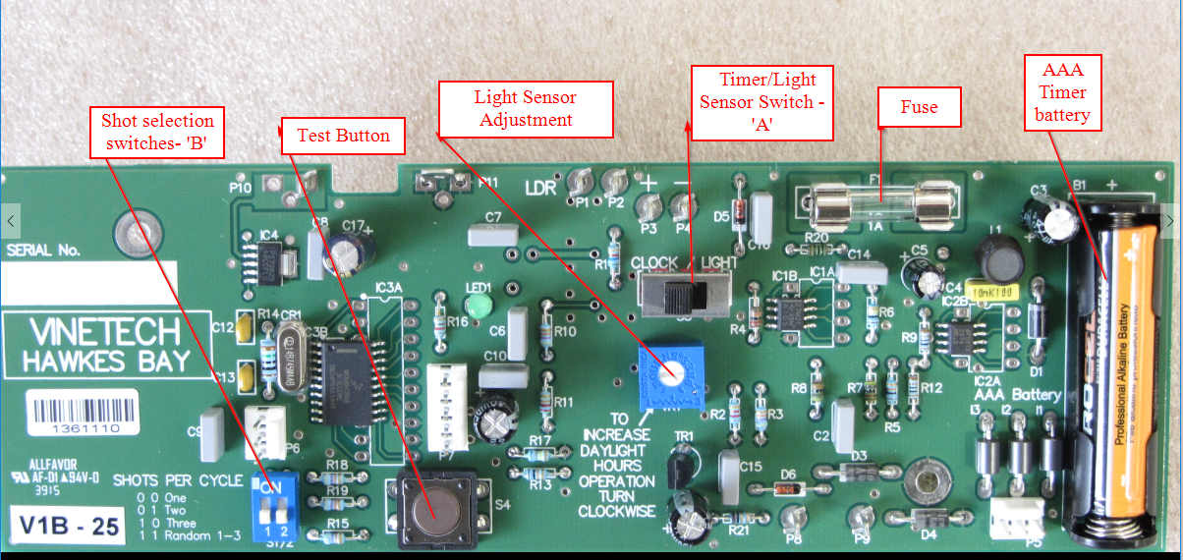

PCB BOARD – TEST BUTTON

1. Battery Condition When first switched on, the LED will light for 10 seconds and then flash every 10 seconds. This indicates the circuit board is powered up and working OK. Press and immediately release the test button. This will indicate the conditions of your battery:
- 4 flashes – over 12 volts.
- 3 flashes - good
- 2 flashes – becoming marginal

2. To Test Fire – Press and hold button until LED stays on. This is best done with the gun lying down and gas turned off. After releasing button, you should hear a click followed 2 seconds later by a series of ticks. This will indicate that the solenoid and spark are working OK.

END OF SEASON STORAGE

- At seasons end or start, remove hose from the regulator by unscrewing the fitting, spray short burst of CRC into hose, reconnect and turn on the gas, run birdscarer for a couple of sequences. This will clean any “sticky gas” residues from the solenoid.

- Disconnect the regulator from the gas bottle and cover the end with the protective cover which has been stored in the control box.

- Remove the main 12v battery and the AAA timer battery at seasons end. Charge the 12v battery and store. During the off season, check battery and recharge if necessary. The timer battery is located beneath the timer on the main board. Remove the timer for access.

- Cover the end of the barrel to prevent birds and wasps building nests.

- Grease the tripod pivot assembly.

Timer Instructions
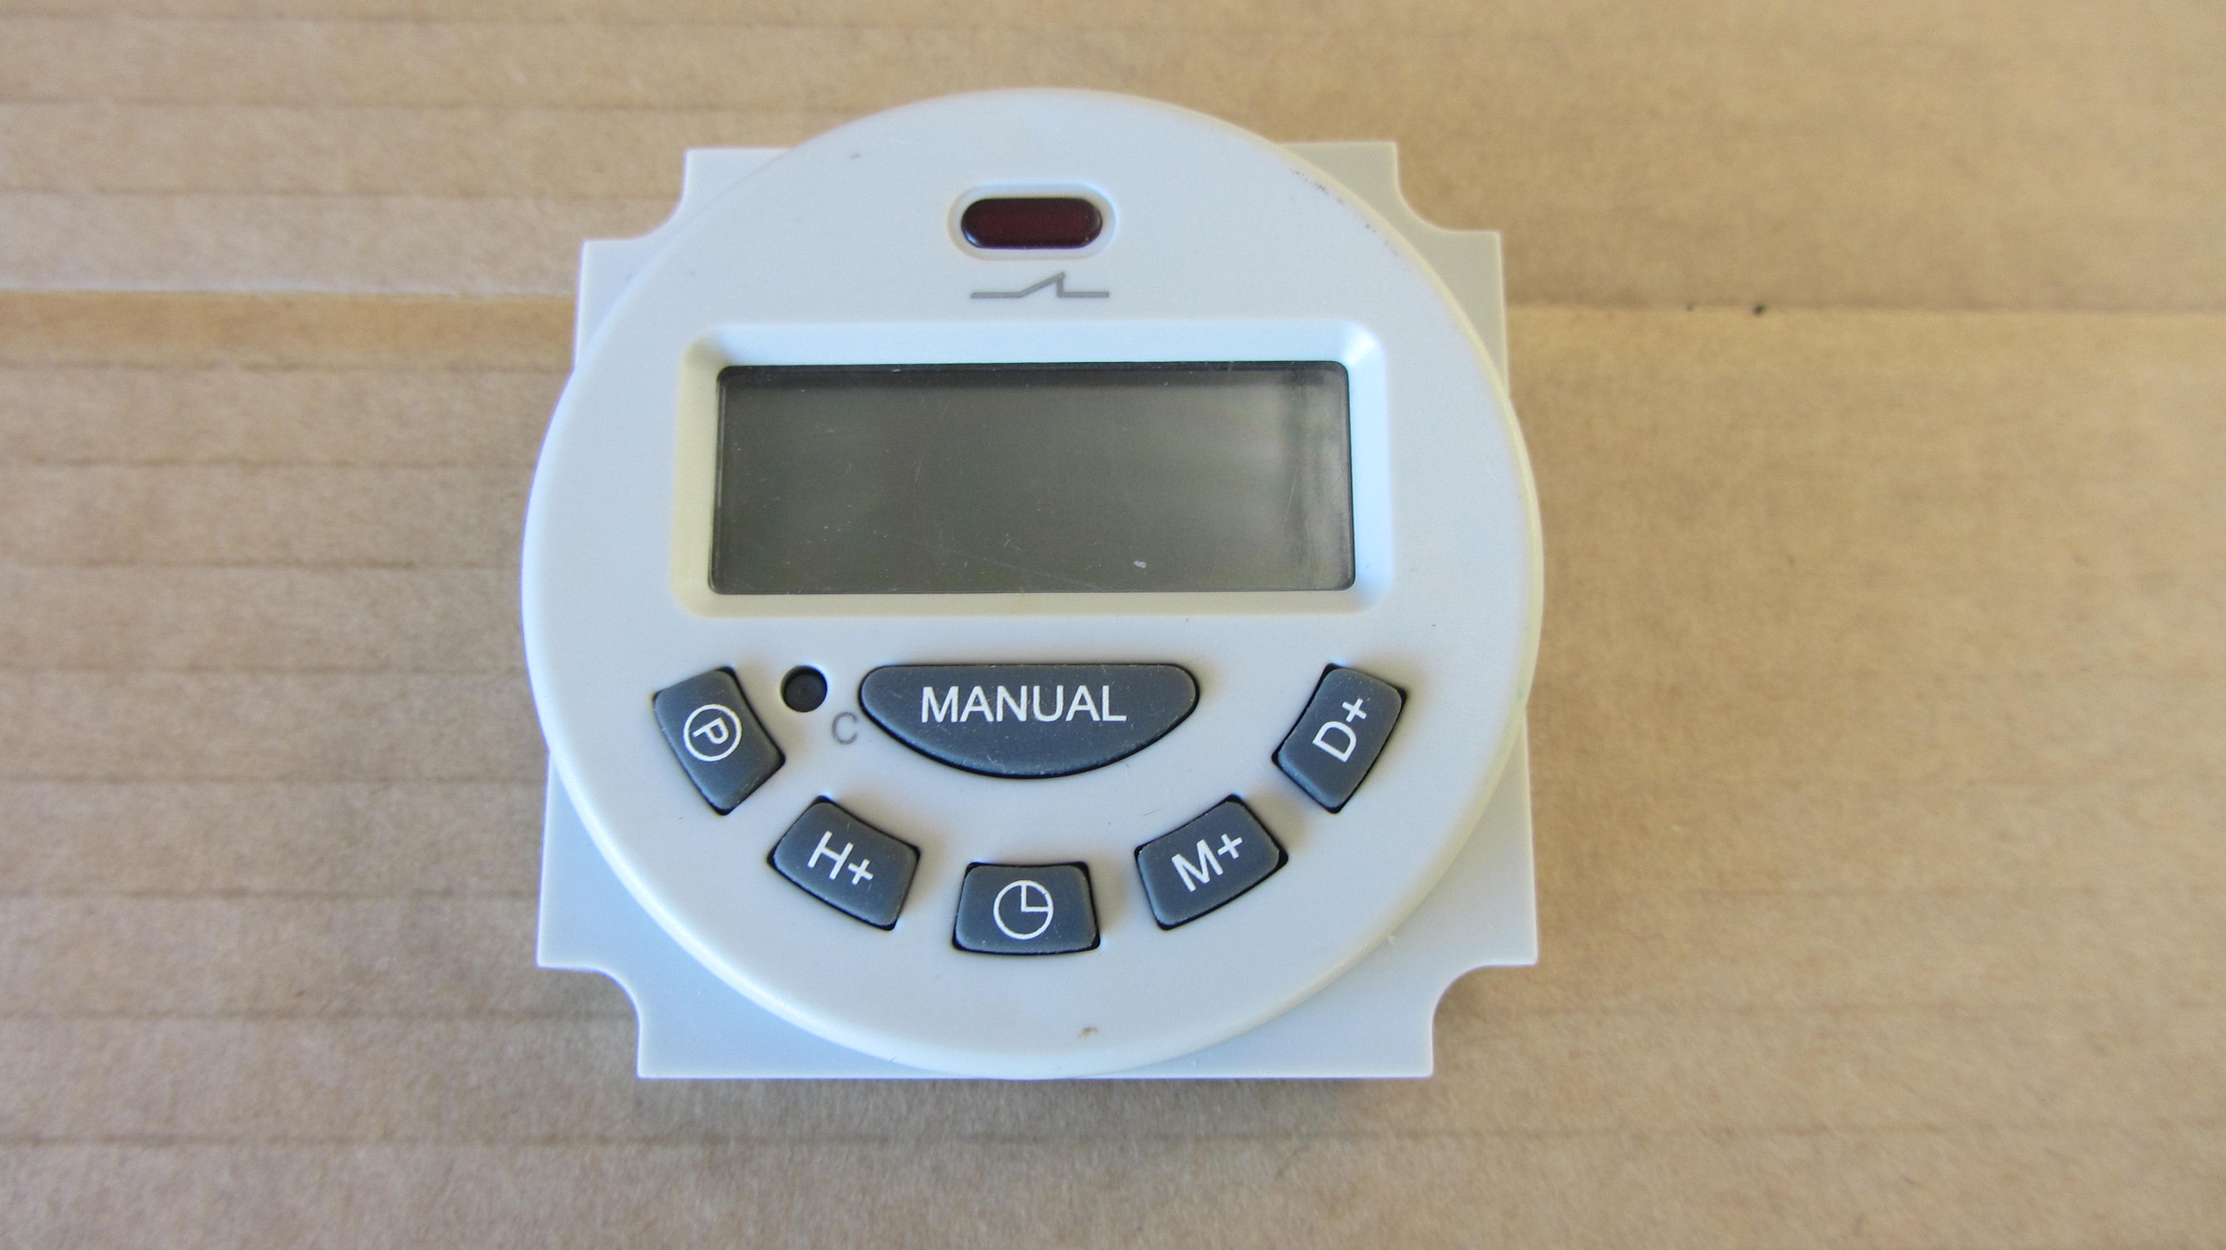

- Clear all timer settings with the cancel button (c) before starting programming.
- To set the current time, press and hold, press D+ for the day, H+ for the hour and M+ for minutes.

- If you wish to have the same on/off times for every day of the week, you only require one setting.
P
- Press and release
- Push the day button until all the 7 days of the week are showing along the top. (displays 1 ON)
- Set the ON time press H+ /M+ for the ON time required, remembering it is a 24 hour clock.
- Press P again (displays 1 OFF)
- Set the OFF time – press H+/M+ for the OFF time required, remembering it is a 24 hour clock.
- Press to return to the time of the day. Setting complete.

- It does not matter what time of the day you set your timer, it will start its sequence as soon as you have finished programming, e.g. the timer will begin immediately and your birdscarer will be operational once you have turned it on.

- You can have up to 16 ON and OFF times during a 24 hour period.

- If you wish to have ON/OFF times on specific days rather than for the whole week
- Press P and release
- Push the day button and select the day or days of the week required showing along the top. (displays 1 ON)
- Set the ON time press H+ /M+ for the ON time required, remembering it is a 24 hour clock.
- Press P again (displays 1 OFF)
- Set the OFF time – press H+/M+ for the OFF time required, remembering it is a 24 hour clock.
- Repeat timer ON/OFF settings for any additional day or days
- Press to return to the time of the day. Setting complete.

- The cancel button (c) requires a pen or something similar to clear all settings.

TROUBLE SHOOTING
Problem 1

Birdscarer will not go at all (Note: when first turned on there will be a 35 sec delay before the first firing)
Likely Cause
- Flat battery
- Light sensor set too low for the conditions
- No spark

Remedy

- Check the battery is in good condition, properly fitted and fully charged.
- Adjust the light sensor adjustment as described in Option 1 of the instructions.
- Check the spark plug and heat sensor wires are connected. If good, remove the wires and spark plug. Check for fouling and the correct 2mm gap.

Problem 2

Birdscarer will not go even though gas can be heard entering the barrel and 2 seconds later, a series of ticks can be heard indicating spark.
Likely Cause
- Stale or insufficient gas
- Poorly adjusted regulator
- Spark plug gap too narrow
- Obstruction in the jet
- Obstruction in the barrel

Remedy

- Purge your gas bottle as per instructions on page 3. Even if your gas bottle is new a layer old gas can be trapped on top of the new gas.
- Check the regulator is in the factory set position (2-bar) as per calibration on the side of the regulator.
- Check spark plug for fouling and ensure it has the correct 2mm gap.
- Disconnect gas hose and remove the jet from the barrel, clean with a pin or similar to ensure there is no obstruction and refit.
- Check the barrel is clear. The obstruction (birds nest!!!) is usually at the very base of the barrel upsetting the gas/air mixture.

Problem 3

Birdscarer will not go and gas can be heard entering the barrel but no series of ticks can be heard indicating no spark.
Likely Cause
- Flat battery
- Spark plug problem

Remedy

- Recharge battery
- Remove park plug, clean, reset gap if necessary to 2mm, and refit.

SOLAR PANEL KITSET

Vinetech have a solar charging option available which can be easily retro fitted to your birdscarer.

HALF HEIGHT TRIPOD OPTION

This is a useful option when height is not required, e.g. for crops etc or in high wind areas.

Ensure the gas hose is configured as per the picture to allow the gas bottle to rotate unobstructed within the tripod. The gas bottle must be clear of the ground.
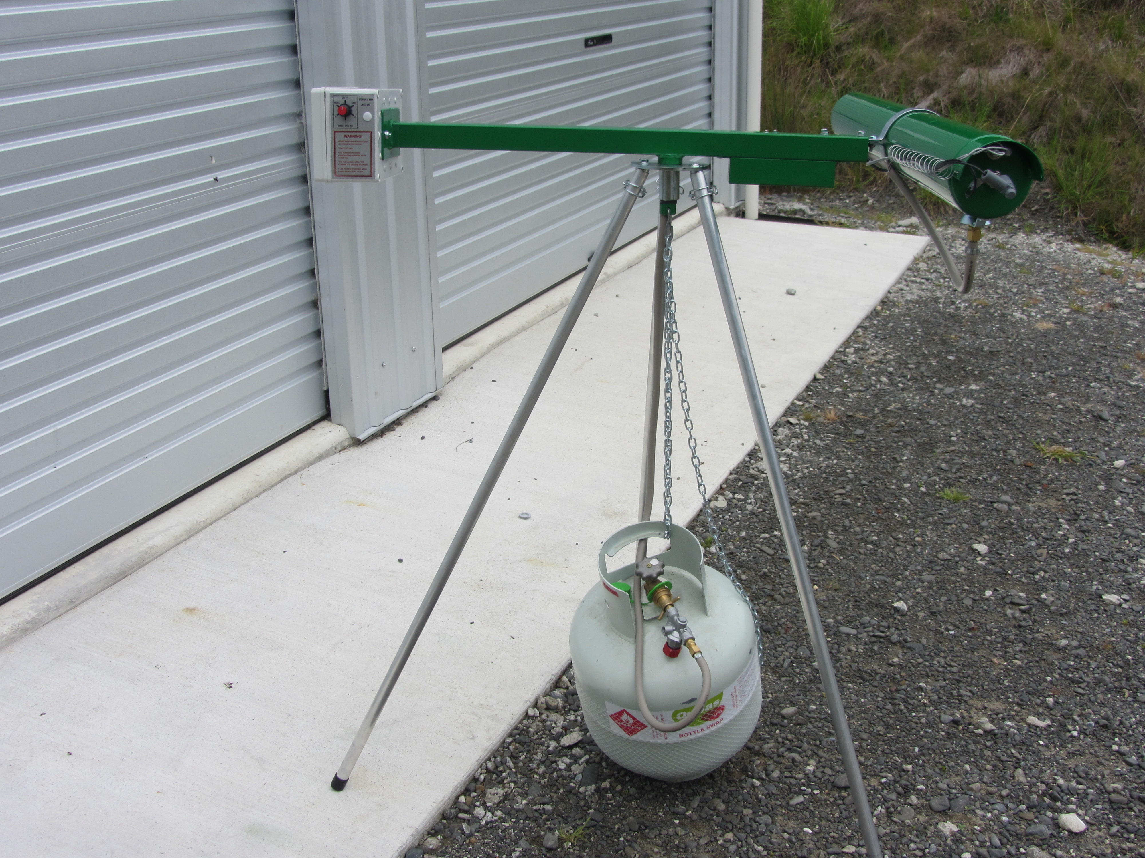
Use the extra end covers provided so the inside of the legs don’t get clogged up .

